**Vehicle Ecosystem Using IoT and Blockchain Technology**

***Author’s Details***

***Main Author:***

*Laksh Lalwani*

*2019laksh.lalwani@ves.ac.in / lakshlalwani71@gmail.com*

*507, Ganesh Nagar, Near Chemist Bhavan, Jalgaon 425001*

*+919309762203*

***Co-authors:***

*(1) Shubham Goswami*

[*2019shubham.goswami@ves.ac.in*](mailto:2019shubham.goswami@ves.ac.in)

*8208087023*

*(2) Dheeraj Yadav*

[*2019dheeraj.yadav@ves.ac.in*](mailto:2019dheeraj.yadav@ves.ac.in)

*9892499375*

*(3) Mrs. Priya R L*

[*priya.rl@ves.ac.in*](mailto:priya.rl@ves.ac.in)

*Mob: 9167093201*

*(4) Richard Joseph*

[*richard.joseph@ves.ac.in*](mailto:richard.joseph@ves.ac.in)

*Mob : 8879585434*

**Abstract**

The Regional Transport Office (RTO) in India is a government body responsible for enforcing motor vehicle regulations. Its functions include issuance of driving licenses, vehicle registration, collection of taxes and fees, and enforcing traffic laws. The RTO system has faced challenges such as irregularities and inefficiency, however, efforts have been made to improve the experience through digitization and online services. Despite these efforts, the system still faces issues such as long wait times and backlogs of pending applications.

The proposed model aims to track and record information about vehicles for traffic monitoring and ticket generation using IoT and blockchain technology. The process includes: (1) collecting data from various sensors from vehicles and signal cameras for traffic violations such as overspeeding or running red lights, (2) creating a blockchain for vehicle information and traffic rule violations, (3) using sensor data and camera footage to issue tickets with video proof for users to verify or contest, (4) queries on issued ticket by the accused is managed in a separate Complaint tracking Blockchain and ticket's status is updated accordingly, (5) using crash detection sensors and GPS to send an emergency message with location information to designated individuals appointed by the RTO.

**Introduction**

The centralized RTO system in India is a government-run program responsible for the issuance of driving licenses and registration of vehicles. It is managed by the Ministry of Road Transport and Highways and operates through various RTO offices located across the country. The main purpose of the centralized RTO system is to regulate and monitor road traffic and maintain records of all vehicles and drivers in the country.

The centralized RTO system in India is responsible for issuing driving licenses, registering vehicles, collecting road taxes, enforcing traffic rules and regulations, and monitoring and controlling road safety. The system uses a computerized database to store information about vehicles and drivers, making it easier to track and manage records. The centralized RTO system in India also includes various services such as renewal of driving licenses, transfer of ownership of vehicles, issuance of permits, and more. However, using the centralized database for maintaining records may include several drawbacks such as manual data entry without validation, resulting in incomplete or erroneous data. There is also the lack of adequate management systems for updating information on car conditions, leading to insufficient information for buyers on the used car market. The insurance companies often have to pay out on fabricated claims despite making the driver business responsible for their mistakes.

**Related Works**

[1] This patent details a collision detection system that can be installed in vehicles. It operates by utilizing sensor data gathered from the sensing system of the host vehicle or that of other vehicles to detect potential collisions with nearby pedestrians, vehicles, and road hazards. The collision detection model created by the system includes information on the position, orientation, and size of the colliding objects. To enhance the accuracy of its model, the system may also collect supplementary data from other cars. The system is capable of actively or passively monitoring for possible collisions and transmitting or storing the data. Access to the monitoring data can be provided to requesters via a network-accessible service. Notably, this patent solely pertains to collision detection and does not address the broader traffic system.

[2]This patent outlines a methodology for coordinating automobile repairs using a database that stores statistics for each body shop. The data is automatically updated with inputs from repair shops, insurance carriers, and other sources and contains relevant information such as available capacity, customer satisfaction, cycle time, employee satisfaction, and labor productivity. The method also involves a platform for managing insurance claims and informing concerned parties about repair events associated with an automobile. This platform includes an input/output unit, a memory, and a processor that interfaces with insurance company and repair shop computers. The updated statistics in the database are utilized for insurance claim processing based on repair task data. However, it should be noted that this patent only deals with the creation of a database for handling insurance claims and does not address traffic regulations and rules.

[3] This invention pertains to a method, system, and computer-readable medium for managing blockchain transactions. The system and method comprise a CPU and memory, enabling recognition of blockchain transactions, examination of their contents, and evaluation of whether to accept or reject them based on said contents. The computer-readable medium stores instructions that, when executed by the processor, result in specific actions being performed. The process includes scrutinizing the blockchain transaction for prohibited content and determining its acceptance or rejection based on the content. It is important to note, however, that this patent can only be used to verify the authenticity of a transaction, as it exclusively identifies invalid transactions.

[4] This patent describes a vehicle configuration and activity history tracking system based on blockchain technology. The system comprises configuration and activity history tracking software on a data processing system that reads vehicle configuration and history blockchains stored at different nodes in a vehicle configuration and history blockchain network. The software compares the blockchains to determine their validity and initiates maintenance operations or modifications of the vehicle based on the valid blockchain. In another embodiment, a node in the blockchain network receives requests for vehicle configuration and history blockchains from the software, determines whether the software is authorized to access the blockchains, and sends information from the blockchains to the software if authorized. The various features and functions of the system can be achieved independently or combined in different embodiments. It is worth noting that this patent solely employs a blockchain to record the configuration of vehicles, which can only be modified in response to changes in the historical blockchain. The primary focus of this patent is to facilitate the maintenance of the vehicle as a whole.

[5] This patent describes a second-hand vehicle transaction method and server that solves problems with tampering and authenticity of transaction data. The method includes receiving vehicle sales information and a sales smart contract from a seller, registering the information and contract in a blockchain, receiving a transaction request from a buyer, searching for matching sales information, and executing the sales smart contract. Optionally, the method may include evaluating the vehicle and generating a vehicle condition evaluation report, generating a usage smart contract, and reviewing the target vehicle condition evaluation report. The server includes a memory storing an executable program that can receive the sales information, register it in a blockchain, receive transaction requests, and execute the sales smart contract. It is important to note that this patent exclusively utilizes a blockchain to record the sale price and related details of second-hand cars, as provided by the seller. However, it does not encompass the entire history of the car, spanning from its production to its resale, which can significantly impact the vehicle's sale price.

[6] This patent describes various embodiments of a method, apparatus, and computer readable storage medium related to storing and validating sensory or motor vehicle data on a blockchain. The method includes receiving sensory or motor vehicle data, storing the data in a blockchain, performing a validation of the data based on validation standards, and storing the results of the validation in the blockchain. If the validation standards are not satisfied, a required corrective action is identified and a request for the corrective action to be performed is transmitted to one or more registered entities. The computing entity then receives a confirmation that the corrective action is complete and stores the confirmation in the blockchain. The apparatus and computer readable storage medium implement the same process. However, the system is not configured to handle situations where the sensors may be faulty and may store wrong data.

[7] This patent describes a method for storing driving record information generated from a vehicle equipped with driving assistance or autonomous navigation functions on a blockchain. The information stored includes vehicle status, driving control, vehicle surrounding, and vehicle condition information. When an event such as an accident, user request, or vehicle breakdown occurs, the relevant driving record information is extracted, converted into transaction data, and transmitted to a consortium blockchain network system. To protect personal information and privacy, the data is encrypted and verified. The driving record information can be transmitted through a public network, a traffic communication facility, another connected vehicle, or a communication facility with the best communication conditions. However, this patent focuses on capturing sensor data only for certain predetermined actions and not for other factors such as traffic rules violations.

**Block Diagrams**

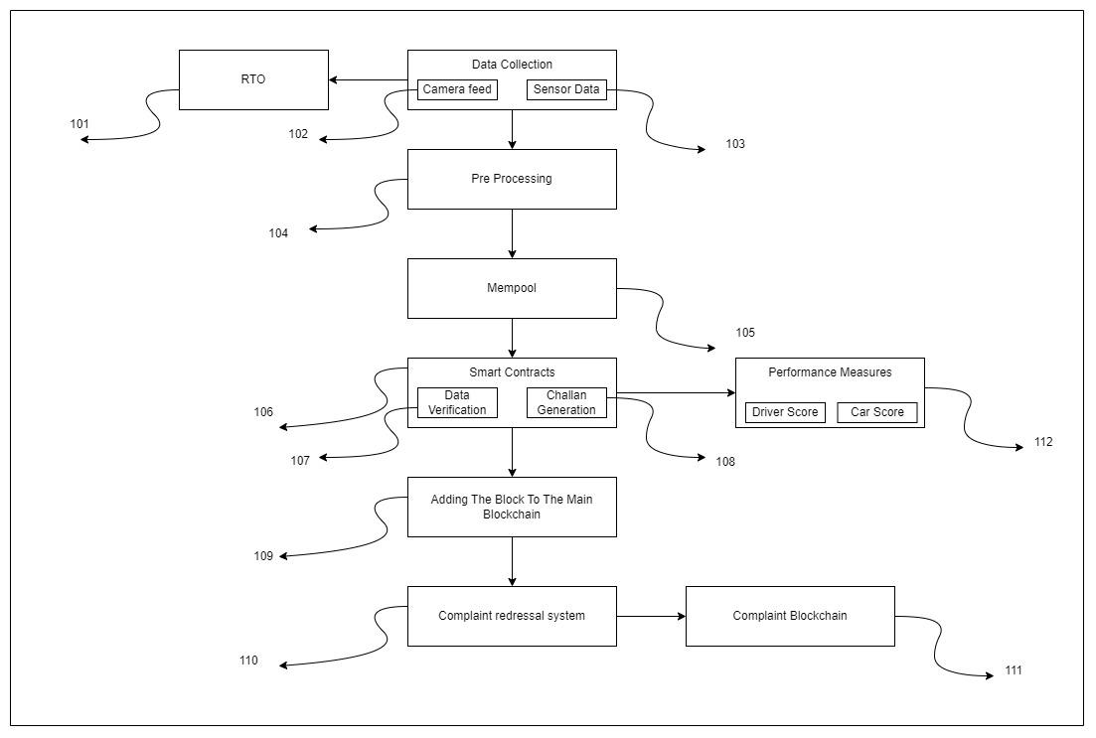

**Figure 100: Conceptual Diagram of the Vehicle Ecosystem**

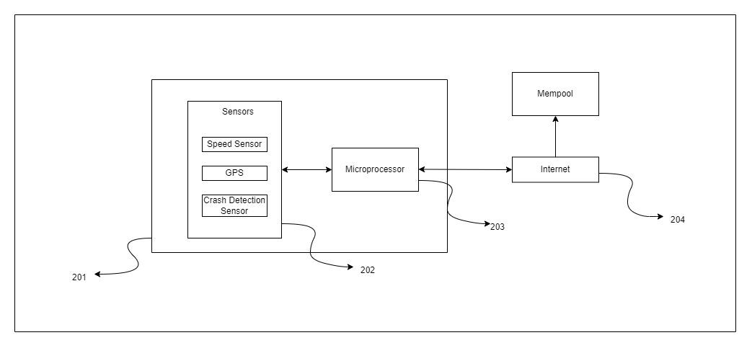

**Figure 200: Hardware Structure of the Vehicle Ecosystem**

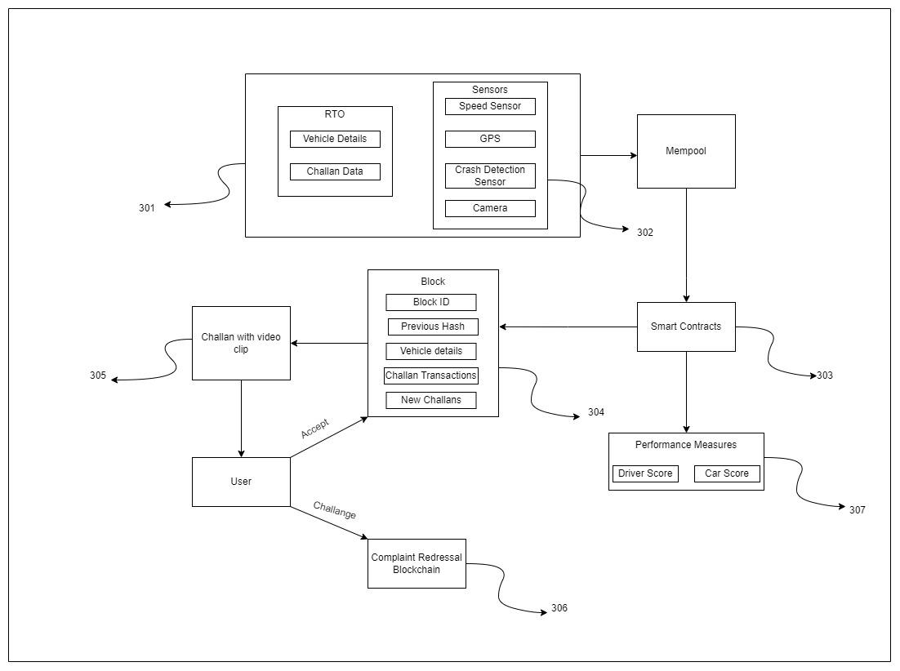

**Figure 300: Flow Diagram of the Vehicle Ecosystem**

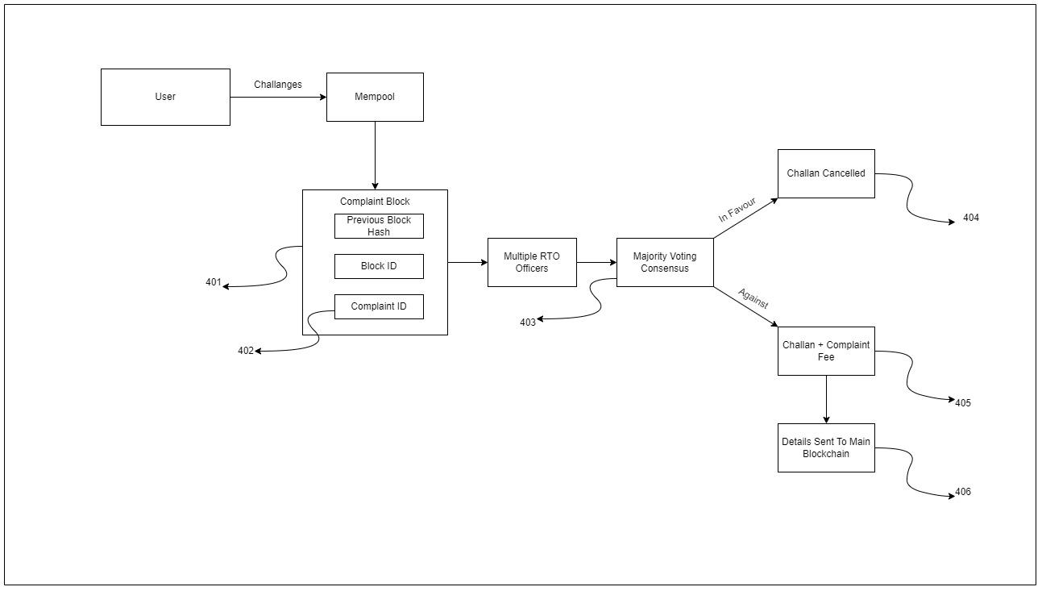

**Figure 400. Compliant Grievances Model**

**Summary**

Vehicle information and challan generation using blockchain technology is a novel and innovative solution to manage data related to vehicles and traffic violations. The implementation of blockchain in this system ensures that the data is secure, transparent, and tamper-proof.

In this embodiment, all vehicle information such as registration details, owner information, and insurance information, PUC, challan information and complaints against a challan can be stored on the blockchain. This not only improves the accuracy and reliability of the information, but it also makes it easily accessible to the relevant authorities. Moreover, the use of blockchain eliminates the possibility of data tampering and fraud, as every transaction on the blockchain is secured with cryptographic algorithms.

In case of a traffic violation, a digital challan can be generated and stored on the blockchain and a camera feed for the same could be sent to the owner registered with the concerned vehicle. This not only ensures a tamper-proof record of the violation but also eliminates the need for manual record-keeping, reducing the chances of errors and fraud. The system can be integrated with traffic enforcement cameras, making it possible to automatically generate digital challans when a violation occurs.

The use of blockchain technology in vehicle information and challan generation has several benefits. Firstly, it improves the efficiency of the system, as data can be accessed and updated in real-time, reducing the time and effort required to manage it. Secondly, it provides a more transparent and secure system, reducing the chances of fraud and errors. Finally, it helps to improve road safety by making it easier to enforce traffic rules and regulations, leading to a safer and more efficient transportation system.

In conclusion, the use of blockchain technology in vehicle information and challan generation is a step towards a more efficient and secure transportation system. By providing a tamper-proof and transparent system for managing vehicle information and traffic violations, it can help to improve road safety and reduce the chances of fraud.

**Brief Description Of The Drawings**

The figures presented in the following depict different aspects of the system and methods discussed. Each figure represents a possible embodiment of the system and methods. The reference numbers in the figures identify features that appear in multiple figures and are consistently labeled.

Figure 1. depicts a functional block diagram illustrating an embodiment of blockchain system flow.

Figure 2. depicts the embodiment of hardware components interacting with blockchain technology

Figure 3. depicts the embodiment of block generation as well as challan generation and suitable action for the generated challan.

Figure 4. depicts an exemplary embodiment of challenging the generated challan and creation of ‘complaint blockchain man’.

**Detailed Description**

The current embodiments concern the use of blockchain technology to record information related to processes and services in the automotive sector. For instance, a blockchain can be employed to handle automotive claims, vehicle loss history, and the lifespan of a vehicle. These systems and methods enable the use of a blockchain that provides for private information and restricted participants. They facilitate a shared agreement among businesses, consumers, and authorities regarding the accuracy of information and transactions stored on the blockchain.

Applications can benefit from utilizing methods for streamlined claim resolution, monitoring loss history, tracking new or refurbished parts, and facilitating used vehicle purchases, among others. These techniques and systems may utilize Distributed Ledger Technology (DLT) to create a blockchain where each block is linked to the previous one through cryptography. A blockchain is a decentralized database where transactions are recorded by all participants in the network, consisting of a series of blocks containing a group of transactions that are agreed upon by all users in the network through consensus. When a new block is added, all users must reach agreement, and if consensus is achieved, the changes are reflected on all nodes in the blockchain. However, if consensus is not reached, the changes are rejected. This makes the blockchain different from centralized systems where control is maintained by a central party.

Blockchains can be public, meaning the system is open, decentralized, and enables consensus from all users to authorize changes to the blockchain. However, these permissionless and decentralized blockchains have limitations and may not be suitable for sharing or recording confidential information. To create a block, each transaction within it must have a hash value generated through a cryptographic hash function such as SHA256 or MD5. These hash values are combined using cryptographic methods like a Merkle tree to create a single hash value that represents the whole block. This hash value is then combined with the hash value of the previous block to form the header of the new block, linking the blocks cryptographically and forming a blockchain.

Information stored on a blockchain is trustworthy because each new block is secured by a hash value and a nonce (a one-time random number) used as inputs in a cryptographic challenge. The difficulty of the puzzle can be set by network participants or administrators. A node solves the cryptographic puzzle by continuously altering the nonce value in conjunction with the new block's hash value until the puzzle's solution is found, which must meet certain criteria (e.g. starting with a specific number of zeros). Once the solution is found, the node publishes it for other nodes to verify its validity. However, if a node attempts to alter a transaction in the blockchain, it will not be accepted by other nodes in the network as the hash value is cryptographically secure and changing a transaction would change the hash value.

Figure 100 illustrates a functional block diagram, which comprises various components such as the RTO (101), Data Collection through Camera feed (102) and Sensor Data (103), Pre-Processing (104), Mempool (105), Smart Contracts (106), Main Blockchain (109), Complaint Redressal System (110), Complaint Blockchain (111), and Performance Measures (112). In a typical operation, video and sensor data collected from the camera feed (102) are transmitted to the RTO (101), which serves as the central authority responsible for monitoring traffic compliance and enforcing traffic rules. The collected data is then subjected to pre-processing (104) to clean it before it is added to the Mempool (105), a data structure where the data is stored, sorted, and verified using Smart Contracts (6) prior to its integration into the Main Blockchain (109). The Smart Contracts (106) are a pre-written set of coded rules that execute when certain conditions are met. In this case, the Smart Contracts are utilized for data verification (107) from the RTO database to retrieve vehicle information, check various parameters such as PUC status, insurance expiration, and other details, which are fetched from RTO API based on the vehicle, and then generate Challans (108). The vehicle information and challan details are then appended to a block and added to the Main Blockchain (109). If a vehicle owner receiving a Challan wants to raise a query against the challan, then they may file a complaint with the Complaint Redressal System (110) along with valid evidence to challenge the Challan. The complaint will be addressed by the Complaint Blockchain (111). Some performance measures(112) can also be included. For example, Driver Score and Car Score is used to assign a score to both the car as well as an individual driver.

Figure 200 illustrates a hardware configuration of the vehicle ecosystem that enables data collection and connection to the blockchain. The hardware components include Sensors (202), a Microprocessor (203), and Internet (204) for transmitting data wirelessly from the sensors to the mempool to create new blocks for the blockchain. The sensors (202) installed in the vehicle can gather information such as speed and location, and the microprocessor (203) can use this data to generate citations for any legal speed limit violations based on the location coordinates. The microprocessor can also send relevant data to the mempool through the internet (204) when specific sensor inputs reach predetermined thresholds. Additionally, the crash detection sensor (202) can trigger a pre-defined or customizable SOS message to designated individuals or contact nearby hospitals in the event of a fatal crash. Note that the sensors described here are not exhaustive and may be modified or added as needed.

Figure 300 depicts a flowchart of the blockchain ecosystem that includes various components such as RTO (301), Sensors (302), Mempool, Smart Contracts (303), a Block (304), Challan Generation (305), Users, Complaint Redressal System (306), and performance measures (307). In some embodiments, data from RTO (301) and the sensors (302) is temporarily stored in the mempool, rather than directly added to the blockchain, to prevent network congestion and data loss.

At (303), smart contracts, which can be thought of as legal contracts in code form, are executed automatically when certain criteria are met. The smart contracts verify the data, which is then added to a block (304) and eventually the blockchain. The block (304) contains various components such as the Block ID, Previous hash, Vehicle details, Challan Transactions, and New Challans. The Block ID serves as a unique identifier for each block, while the Previous hash links the current block to the previous block, helping to establish the blockchain. The Vehicle details include information such as owner details, insurance, PUC, and Challan information.

Whenever a new challan is generated, it is sent to the user with a video clip (305) of the violation so that the user can verify the error and pay the challan if necessary. If the user disputes the challan, they can provide valid proof (the proof may be a medical emergency, FIR in case of a stolen vehicle and/or some other special cases) and challenge it by paying a refundable fee. If a challenge is made, the complaint is transferred to the Complaint Redressal System (306) for further investigation. The performance measures (307) such as driver score and car score can also be added for assigning values to the car based on its conditions and the driver on how he/she drives.

Figure 400 illustrates an embodiment of the Complaint Redressal System that is activated when a user disputes a challan. The system comprises a User, Mempool, Complaint Block (401), multiple RTO officers, Consensus (403), and decisions. The Mempool is designed to temporarily store incoming complaints to prevent network congestion. Complaints are recorded in the Complaint Block (401), which has a unique Block ID and Complaint ID (402), which is shared with the user to track the status of their complaint. Note that this blockchain is separate from the main blockchain that records data and transactions, and is specifically designed for complaint management.

Once a complaint is registered, the evidence provided by the user, along with the relevant video footage, is sent to multiple RTO officers for review. The officers can verify the evidence and the video, and reach a consensus (403) through majority voting. If the decision is in favor of the user, the challan is cancelled (404) and the fee paid to file the complaint is refunded. If the decision is against the user, the fee is not refunded and the issued challan remains in effect (405), requiring the user to pay it. The updated status of the challan is then recorded in the main blockchain.

**References**

[1] Nitto Denko Corp, Elwha LLC, ”Systems and methods for vehicle monitoring“, U.S.   
 Patent US9000903B2, Apr. 07, 2015.

[2] Small Hill, Inc., “Method and apparatus for processing automobile repair data and   
 statistics”, U.S. Patent US20020007289A, Jan. 17, 2002.

[3] International Business Machines Corporation, “Filtering and redacting blockchain   
 transactions”, U.S. Patent US10171509B2, Jan. 01, 2019.

[4] Boeing Co, “Blockchain configuration history for vehicle maintenance, modification,   
 and activity tracking”, U.S. Patent US11315369B2, Apr. 26, 2022.

[5] Launch Tech Co., Ltd., “Second-hand vehicle transaction method and server”, U.S.   
 Patent US20200286132A1, Sep. 10, 2020.

[6] International Business Machines Corporation, “Validation of vehicle data via   
 blockchain”, U.S. Patent US10937253B2, Mar. 02, 2021.

[7] NHN Corp., “Method and system for storing driving record data based on block   
 chain”, U.S. Patent US11442926B2, Sep. 13, 2022.